Stellarverse Studio

Shoot for the Stars

Concept Art

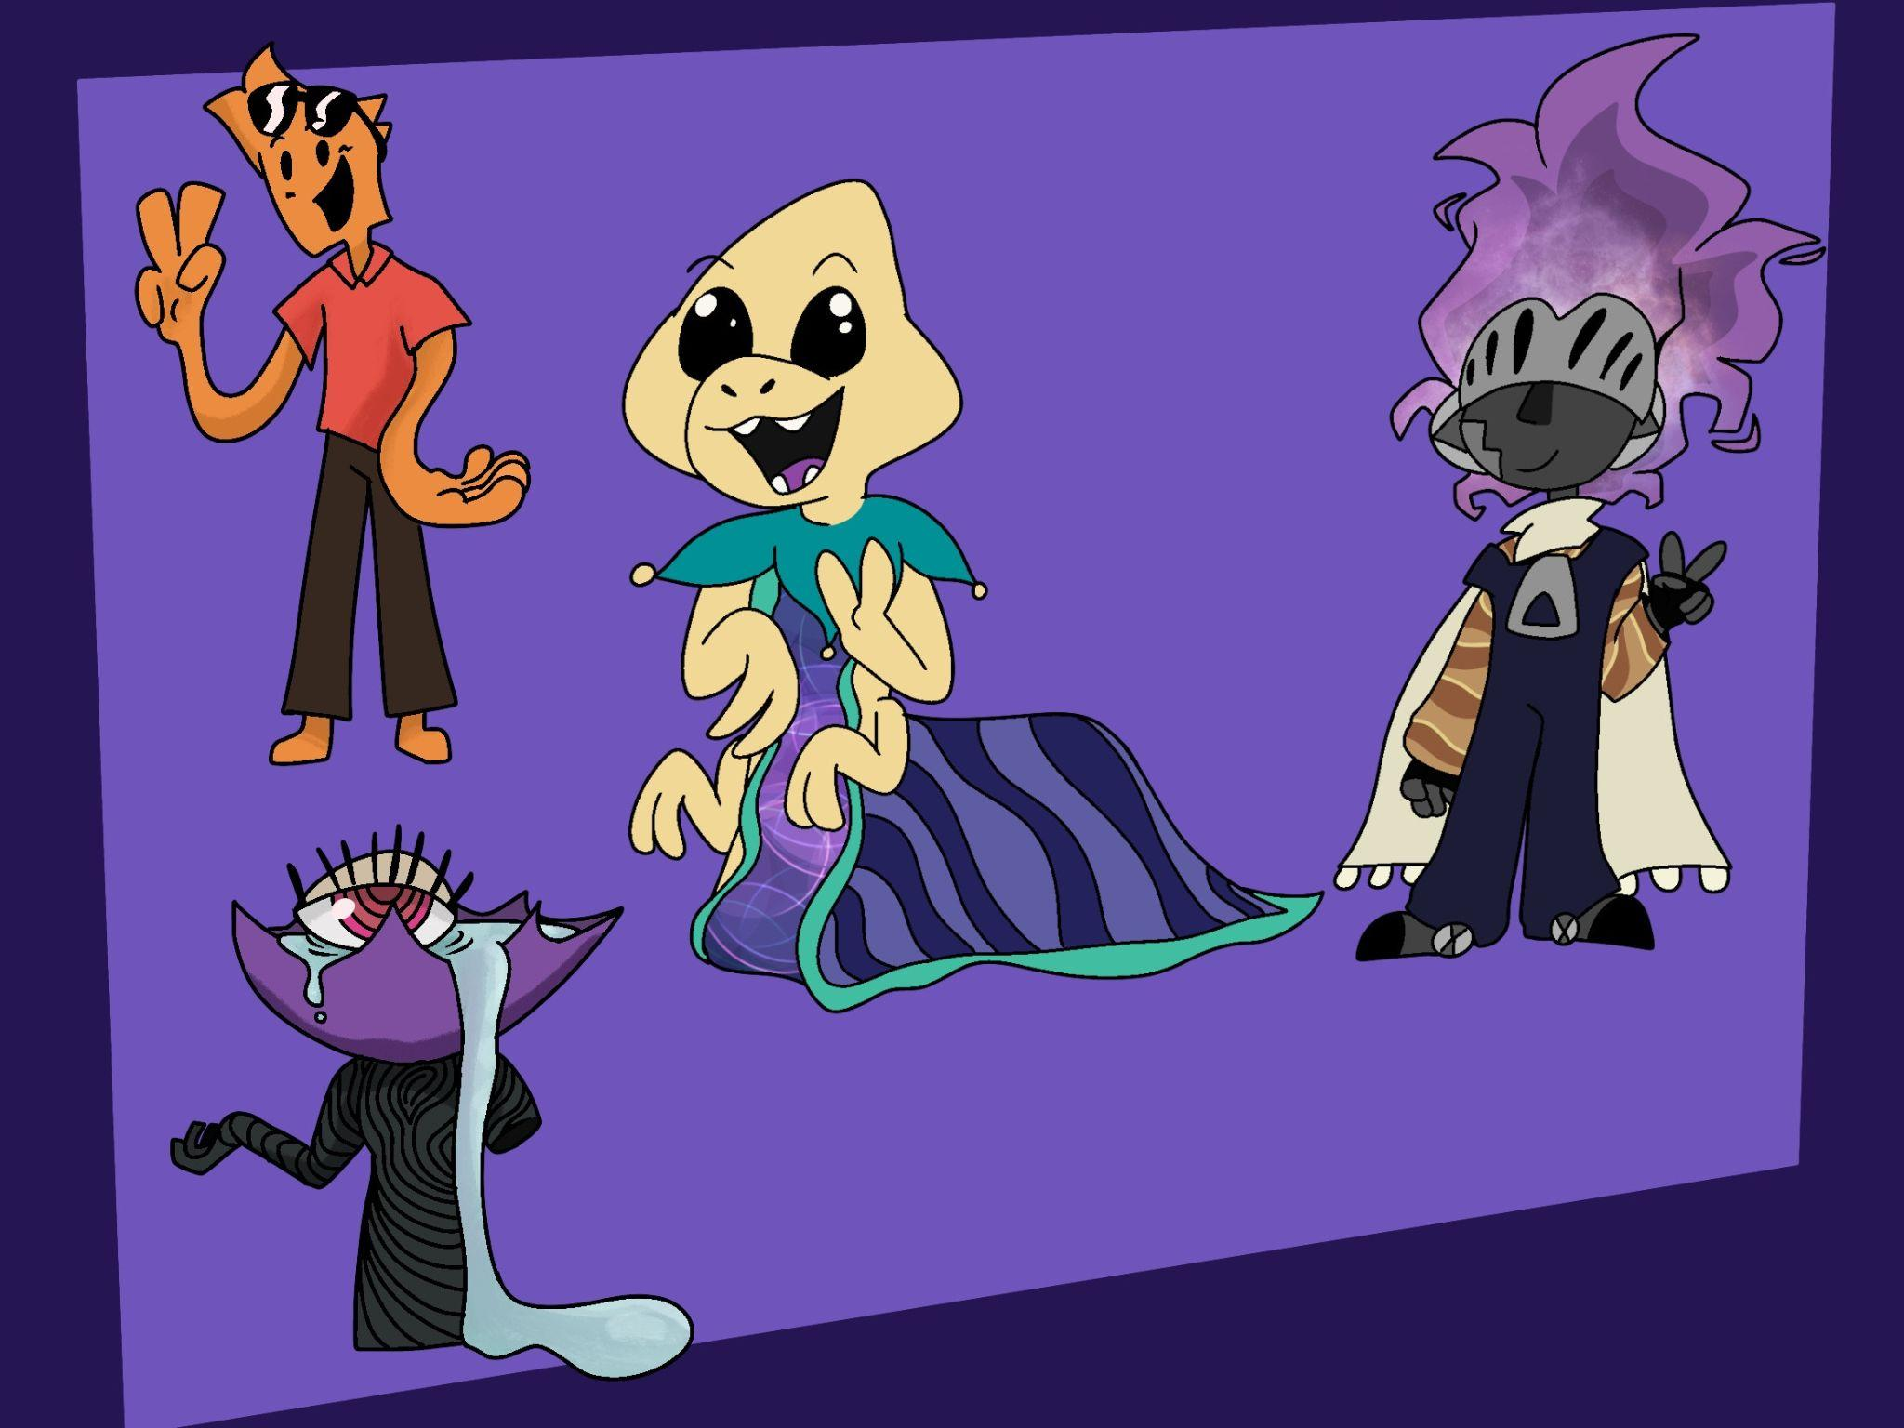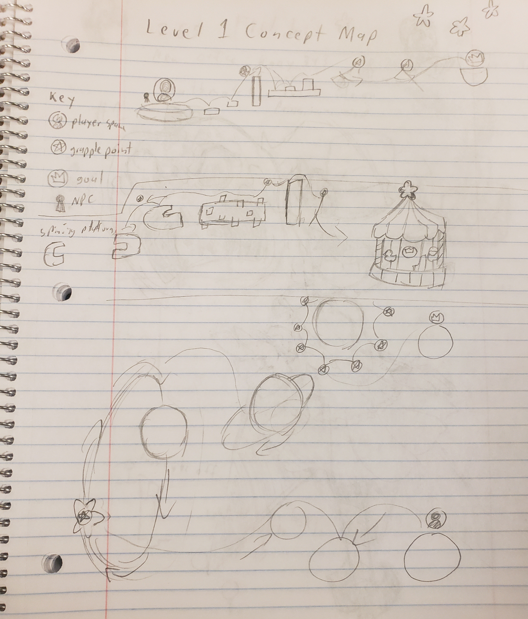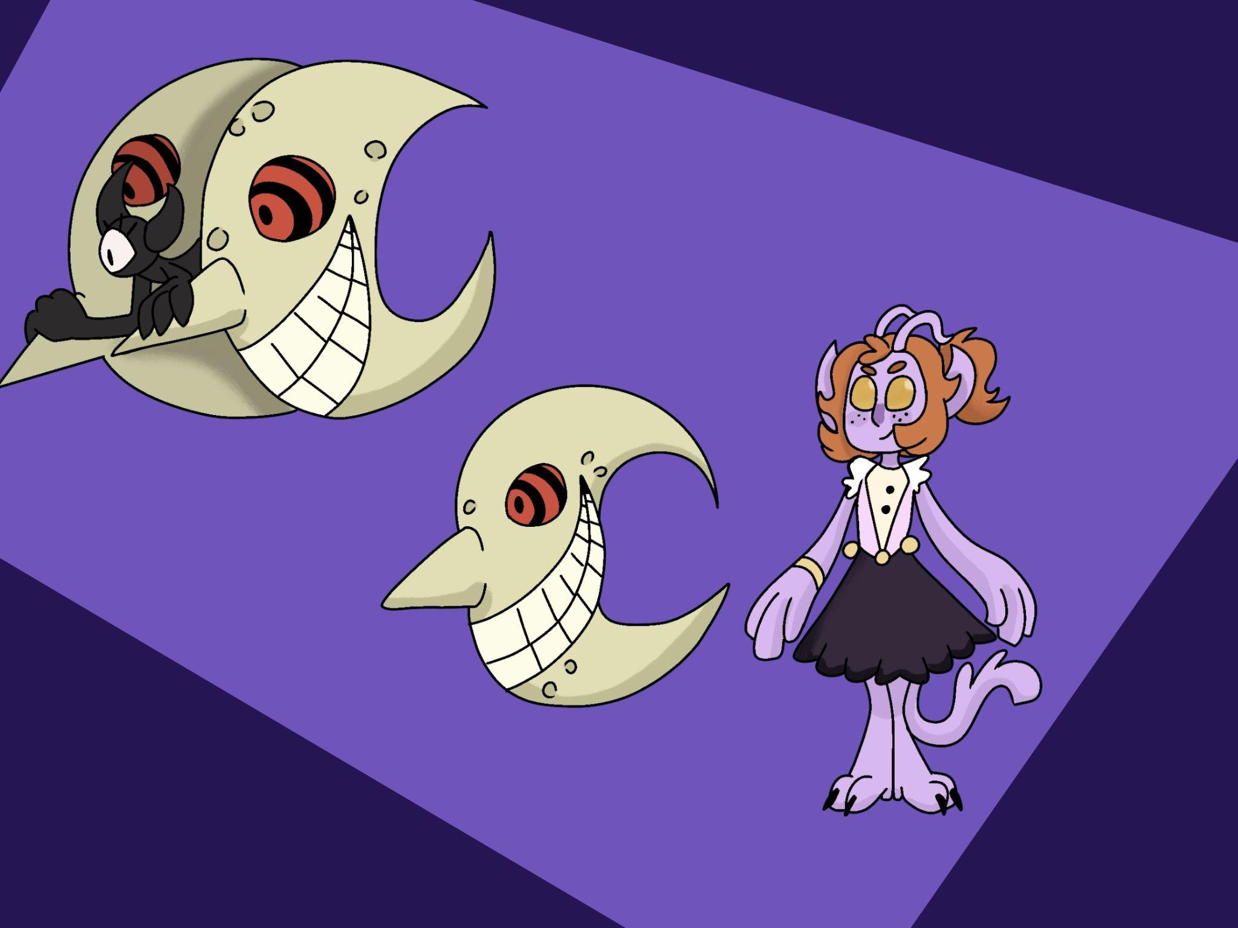

Visual References

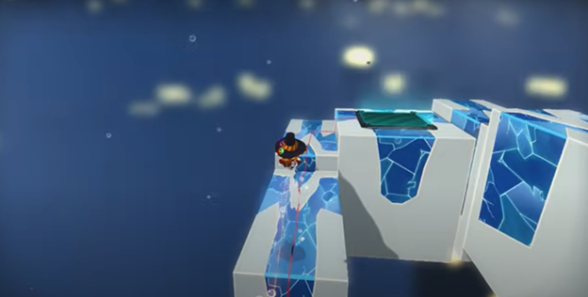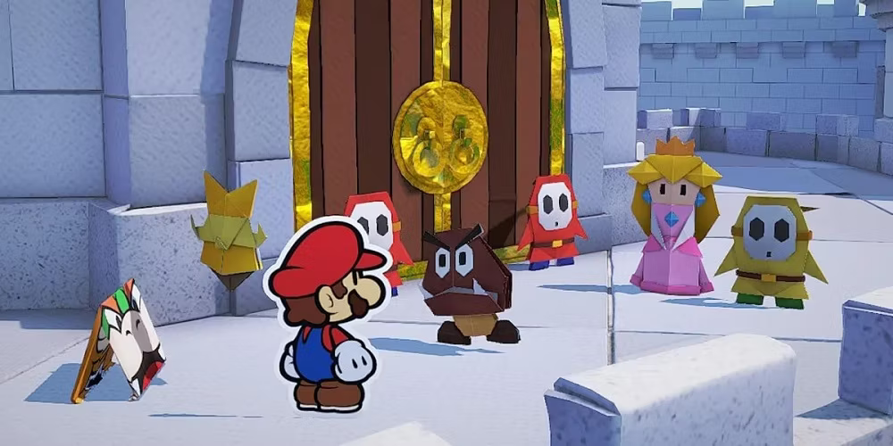

Audio References

Music:

<https://www.youtube.com/watch?v=RKnwapQ9tQQ>

<https://www.youtube.com/watch?v=NyR8LsHJZLw>

[Scavengers Reign Main Title Theme (youtube.com)](https://www.youtube.com/watch?v=uv7ig40ATPo&t=1s)

SFX:

<https://www.youtube.com/watch?v=4DYYfScV7gI>

Game Overview

Our game is a third person platformer with 2D cartoonish characters in a stylized 3D environment. The player is tasked with retrieving lost stars and returning them to their respective constellations. For each star returned, the player gets a small buff to their stats and more story will be revealed. Explore the world with a grapple hook, low gravity and jump pads while avoiding a variety of enemies. The goal of each level will be to safely return the stars without falling or dying.

Lore

In the lore of our game, the world is set in a celestial realm called the "Stellarverse" where stars hold immense power and balance over the universe. Each star is part of a grand constellation that governs various aspects of life, such as wisdom, strength, and creativity. The constellations are like celestial deities, their influence felt across different dimensions and worlds. However, a mysterious force, known only as the "Void," has broken this balance by scattering the stars, causing chaos and instability across the realm.

The player takes on the role of a "Starseeker," a being created by the Astral Watchers, ancient beings who once safeguarded the stars and ensured harmony in the universe. The Watchers have grown weak, their power diminished as the stars have been lost. They entrust the Starseeker with the mission to recover the stars, restore the constellations, and fend off the influence of the Void.

Each time a star is returned to its constellation, not only does the Starseeker grow stronger, but fragments of the ancient history are revealed. The player learns about the rise of the Void, the betrayal of a former Watcher, and the role the constellations play in maintaining balance. These revelations are presented through dream-like sequences, ancient murals, and interactions with NPCs who are remnants of the Watchers' lost civilization.

The enemies the player encounters are corrupted star fragments, twisted by the Void’s influence. Some are creatures of darkness that seek to prevent the restoration of balance, while others are more tragic figures—once protectors of the stars, now consumed by their fall from grace.

As the player progresses, they uncover that the Void was not always malevolent. It was born from a rift within the Watchers themselves—a debate over the true purpose of the stars. One faction believed the stars should be accessible to all beings, spreading their power freely, while the other feared such freedom would lead to exploitation. The Void is the manifestation of that conflict, representing both the destruction of order and the desire for freedom. The player's ultimate task may not just be to defeat the Void, but to find a way to reconcile the fractured Watchers and restore harmony to the realm.

Gameplay Mechanics

The gameplay will involve a mixture of platforming, exploration, and combat. The game loop will involve exploring the world, interacting with things like jump pads and utilizing basic movement as well as your grappling hook to make your way around the world. Enemies will attempt to impede the player’s progress, and the player will be able to either fight them off or avoid them. Eventually, they will obtain a star, making the player stronger and beginning the loop anew. If the player is defeated, they will be sent back to the latest checkpoint.

The primary mechanic in this game is platforming. The player is given various abilities, including a grappling hook, that allows them to traverse the environment and avoid hazards and enemies.

The secondary mechanic in this game is exploration. The player is tasked with locating stars in each level, which requires that they explore the environment to find them.

The tertiary mechanic in this game is combat. Enemies will attempt to prevent the player from moving through the level and collecting stars, and the player will need to figure out how to defeat them or avoid them entirely.

References

We are drawing inspiration from *A Hat in Time*, *Paper Mario*, and *Scavengers Reign*. *A Hat in Time* influences the core platforming mechanics, particularly the fluid, acrobatic movement and the sense of exploration within whimsical 3D environments. From *Paper Mario*, we are borrowing the charm of 2D cartoonish characters within a stylized world, as well as the integration of creative puzzle elements that add depth to the gameplay. *Scavengers Reign* serves as a reference for the aesthetic and atmosphere, infusing the game with a vibrant yet otherworldly feel, blending beauty and danger in a strange, surreal environment.

Puzzles/missions

Some puzzles will revolve around navigating complex environments using the grapple hook, jump pads, and low-gravity mechanics, requiring precise timing and strategic movement to reach hidden or hard-to-access areas. Most missions will focus on retrieving lost stars, where players must traverse treacherous terrains filled with enemies, traps, and obstacles. One level could have players swinging across floating islands while avoiding falling debris, while another might feature a race against the clock as the environment crumbles beneath them. Players will also encounter more intricate objectives, such as solving mazes or using buffs gained from collecting stars to unlock new abilities, creating dynamic and rewarding gameplay progression.

Expected Asset list

| Asset | Priority | Role |
| --- | --- | --- |
| Player sprites | High | 2d Artist |
| Spaceships | High | 3d Artist |
| Grapple hook | High | Programmer |
| Jump Pad Script | High | Programmer |
| Jump Pad Model | Medium | 3d Artist |
| Player Stats | High | Programmer |
| Star Model | High | 3d Artist |
| Low Gravity Script | High | Programmer |
| UI Scripts | Medium | UI Programmer |
| UI Visuals | Medium | 2d Artist |
| Enemy Sprites | High | 2d Artist |
| Enemy Scripts | High | Programmer |
| NPC Sprites | Medium | 2d Artist |
| NPC Scripts | Medium | Programmer |
| High buildings | High | 3d Artist |
| Misc props | Low | 3d Artist |
| Master stylized material | Medium | Tech Artist |
| Respawn | Medium | Programmer |
| Sound effects | Low | Audio Engineer |
| Stars visual effects | Low | Tech Artist |

Milestone deliverable targets

| Milestone 2 | * White Boxed level * Some assets in * Jump pad and basic grapple hook * Animated protagonist |
| --- | --- |
| Final | * 1 fully designed and arted long level * Movement items/abilities * UI/Audio * Creatures/enemies * Animated protagonist |

Tech stack

* Unreal Engine 5.3
* Github
* Blender
* Audacity
* Procreate
* Maya
* Substance Suite
* Photoshop + Illustrator
* Houdini
* Jira
* Confluence